# DGM 260G

# America Kim

# Animation in Maya

# Playback & Time slider Controls

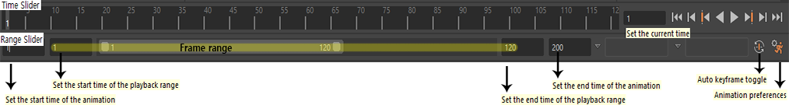

**Tip:** You can make Time Slider binger, Preferences – Settings - Time slider – height.

You can set the maximum frame range is 1 to N as well as the current frame range that you want to focus on while you are animating. To adjust your current frame, you just stretch the frame bar or just typing the start and end frame number on both sides of the frame bar.

**Tip:** If you double click the current frame bar, it will automatically go to the maximum. And if you double click it again he’ll go back to where you less left it.

To playback the animation, there are controls at the end of Time Slider bar. You can look at the entire scene in real time if you press the play button with Playback settings are in real time.

# Animation Preferences & KeyFrames

https://lh4.googleusercontent.com/cnX0xD5u1rCTOsD2pQcGb1EREin2klfGqMiAuDdlx0D61yF8BnuiqtQ51fuGYheVx6je91FQUb7kHvrTyNKN7XLzXcjs0Uvj084IQ91R1punEscVPRLPd5jMIacKnQ3s-zLNV-RO https://lh3.googleusercontent.com/artOtuh7Mb0NctzkZ3PgtR-Z2gVlaQi4Qexkm27oqwGLuFPRcCiLin1Etc4K8OyJexdE9J1gfQyIaswtUdIOUkkWub6WlORqP7GLuJk9UPA40I3SGemzO9xiFAslcjdrPhOGfD5j https://lh6.googleusercontent.com/LNn8stFdorBUCTqP_KDR9WTyrZ6Xjq2U3bCB3B7rw72-LgjK0toidOj9n37Kx86fRjX-Uiy6MIDzy4bH7WTPPL2YlKEwvyjxP127OPMsdrSqOy-Sb6Cs87alJgND3J2r6YRqG__C

or click https://lh5.googleusercontent.com/higeTaXqQenZbwM5Ul3jLOJw7C2g9IJcMOrxKLrDgXeN8RPZpY1gfl4-S-D-9W7hY1rrUDaFlSL8E-YfSeVcBfssY9nsqppDhKJu9bRqbEJ5EJ6bLmsQpK6sEojIuDLrtaMnsh29the Animation Preferences icon in the lower-right corner of the Maya window.

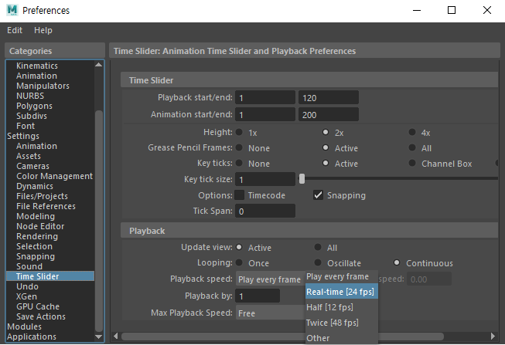

To start animation, let’s create a keyframe. Animation is all about that you are telling the software that you want your object to be in a certain place and position of a certain time.

If you currently have an auto key setup (https://lh6.googleusercontent.com/VSU7PQUG9Km_1mM7uOtSHwV78D6ozpTPrsWKCESa8aF-Nar-IrkpesSg3DkuqBIq2as_X5zvUz2FPbADU2jf9GetRIoXv4u7q9VBgSG8jEAmFHmAm0vDHidvJzNhyUKouLufOWlu), it means that whatever you make some changes in the rig, it automatically creates a keyframe.

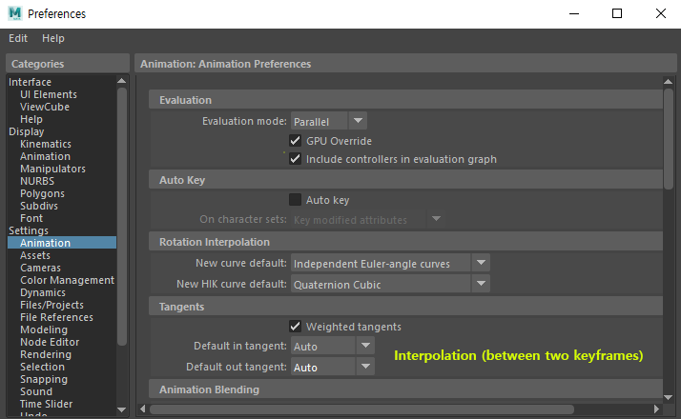v

Select a frame number on the Time Slider that you want to set your object’s movement, then press ‘**S**,’ then a red bar will show up on the Time Slider. (e.g.) https://lh4.googleusercontent.com/j_UIgr5kWQb1WUsROWDocOIhLDLJFqFJQZrrLQFr1HwBG2nSAEIkAL0AHzFVREb3bEwbfrZaTh-ZHWIZUXmoKENYXIrCFDGoZjBmzMs8fE36V6ouHOLBjouWBkHvD_aaPvm7tHP9. You can drag and move, or remove each keyframe on the Time Slider. You can also shrink or stretch frames. Shift + drag to select frames and move yellow arrows. (e.g. https://lh5.googleusercontent.com/-bJBxJFe8P3_jV0iQ9HTgiWGX3kRxOfwDWjOZutgFLAcCM6csS405tPYv3AaHZqR-WNuR1F-q7nNVsRdIUCfXudK5UTnGG2fLyEvLPp5VzvKvyA6kD_Tkd5-TIN1NWESx5mGeRqX

**Tip:** If you want to keep frame specific translate, you can the translation attributes (x,y,z) right click and key selected.

* Shift + W to Keyframe the translate shift.
* Shift + E to Keyframe the rotation.
* Shift + R for scale